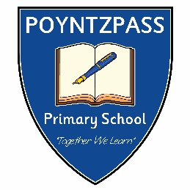**Holidays 2024 – 2025**

**AUTUMN TERM**

*Commences -* Friday 30th August 2024 8.45am – 1.00pm (availability of school lunches will be confirmed, no school buses)

Monday 2nd September 2024 - normal hours, buses & lunches available

*Half term -* Monday 28th October 2024 – Friday 1st November 2024 (inclusive)

*Term Ends* – Friday 20th December 2024 (12noon)

**SPRING TERM**

*Commences –* Monday 6th January 2025

*Half Term -* Monday 10th February – Friday 14th February 2025 (inclusive)

*St Patrick’s Day –* Monday 17th March 2025

*Term Ends –* Tuesday 15th April 2025 (12noon)

**SUMMER TERM**

*Commences –* Tuesday 29th April 2025

*Bank Holiday –* Monday 5th May 2025 &

Monday 26th May 2025

*Term Ends –* Monday 30th June 2025 (12noon)